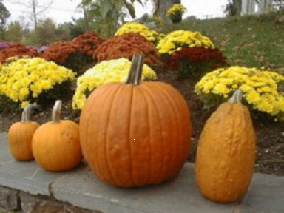


7:00 Open
Call to Order/Pledge of Allegiance
7:30 Citizen Comments
Approval of Minutes
Appointments

7:35 Library Town Hall Study Committee Update

Old Business

- Status Review of FY 15 BOS Focus Areas

New Business

- One Day License Request from Norwell Farms

- Block Party Request – Captain Vinal Way

- One Day License Request from the Silent Chef

- Board of Registrars Appointment

- Cones at Farmers Market

Upcoming Meetings
Announcements
Adjournment
Executive Session

